Deliverable #5

Company: TranspoLogic
Product: FleetConnect

Group members:
Ahmad Habib 23i-0011
Rayyan Qamar Hashmi 23i-0815
Umer Naseer 23i-0663

Section: CS-5B

FleetConnect - GRASP-Based Class & Sequence Diagrams

Class Diagram

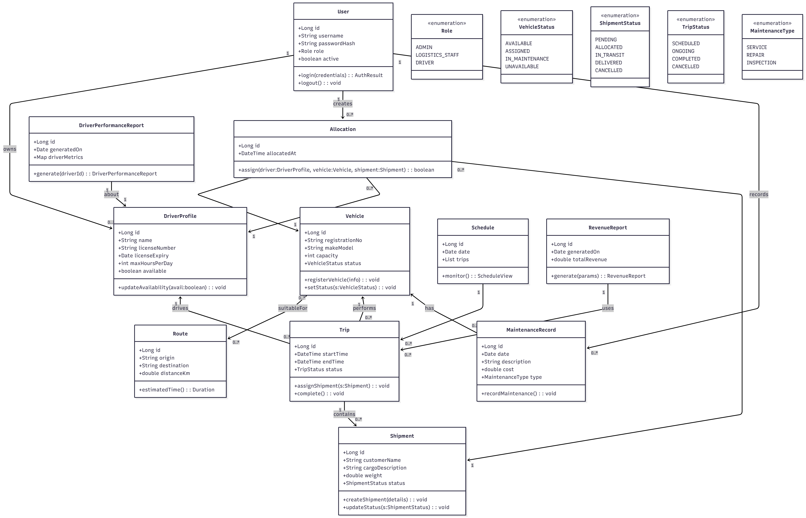

1. Register Vehicle
Sequence Diagram:

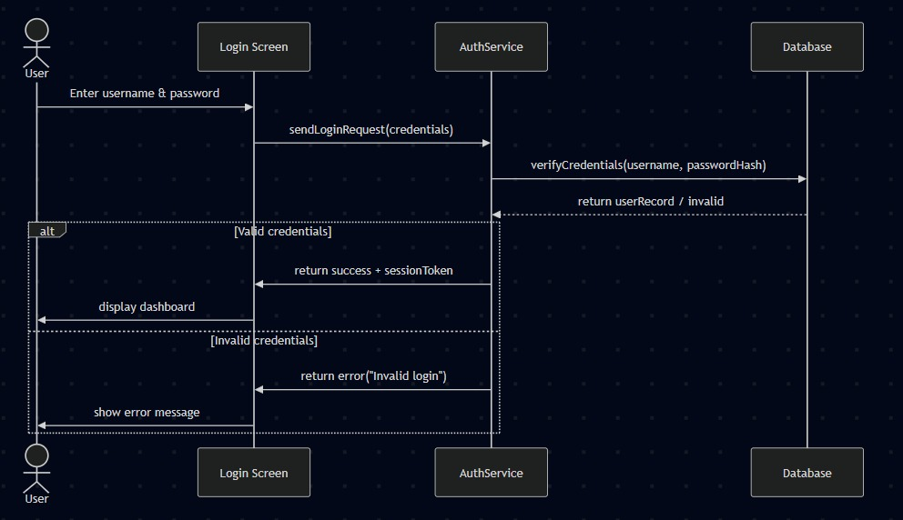

2. Create Driver Profile
Sequence Diagram:

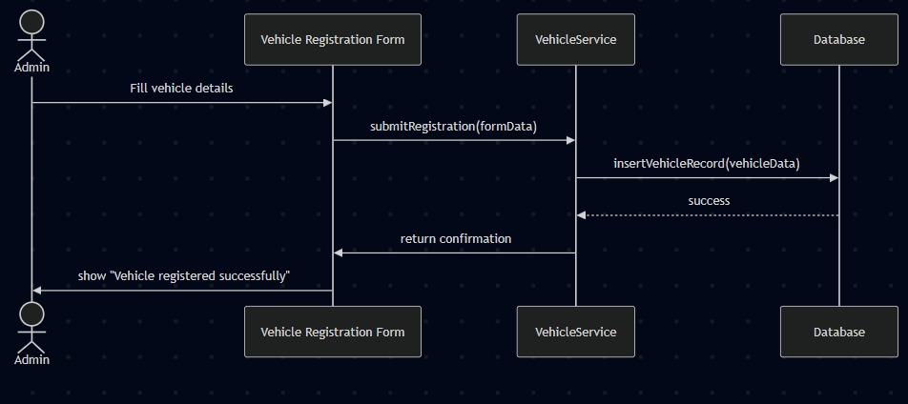

3. Assign Driver to Vehicle
Sequence Diagram:
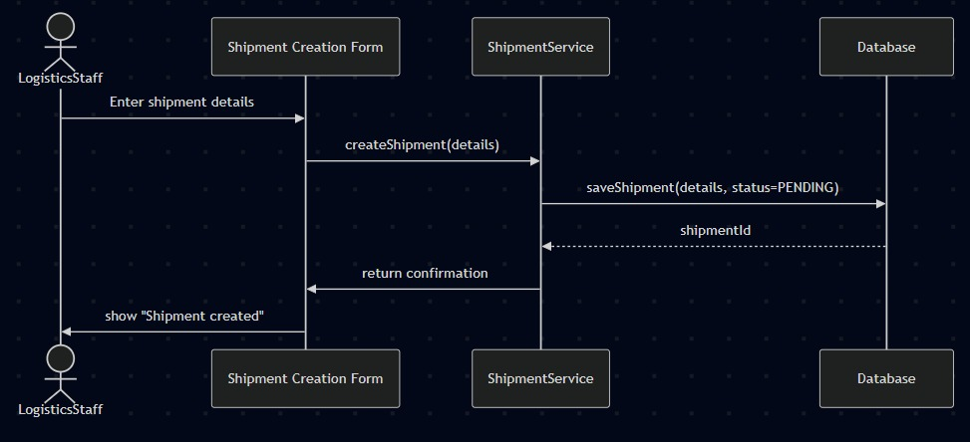

4. Create Shipment
Sequence Diagram:

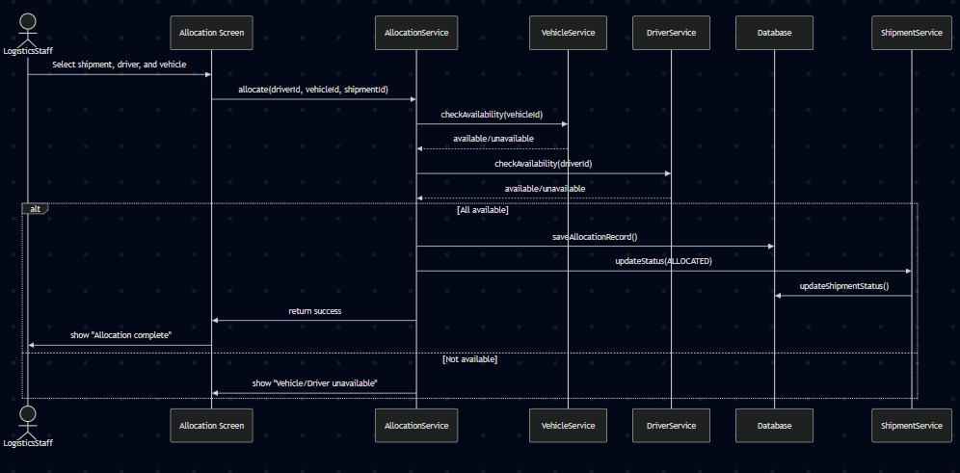

5. Allocate Shipment to Vehicle
Sequence Diagram:

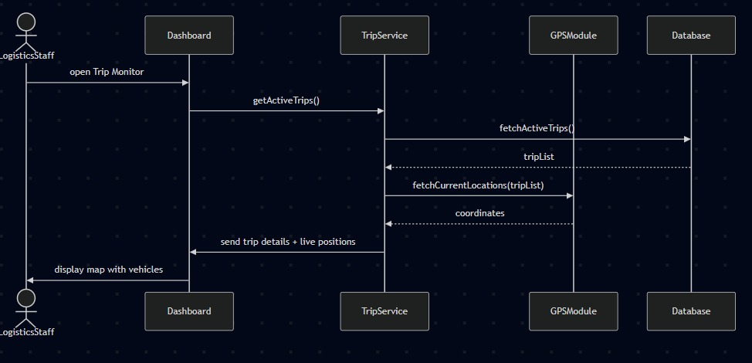

6. Update Shipment Status
Sequence Diagram:
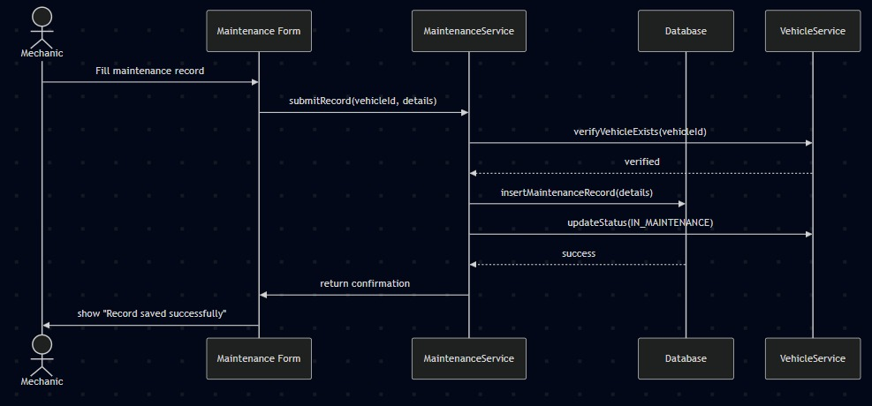

7. Assign Route to Vehicle
Sequence Diagram:

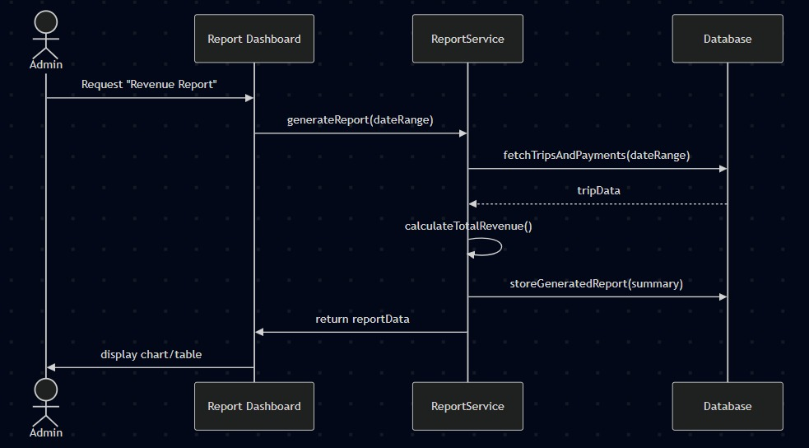

8. Monitor Schedule
Sequence Diagram:

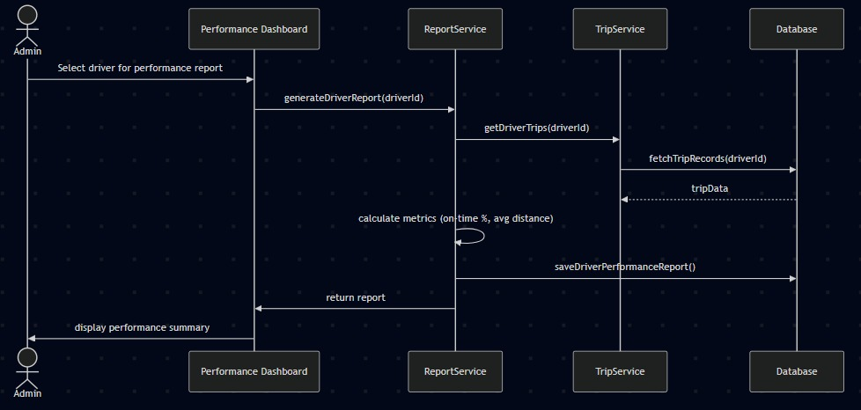

9. Record Maintenance Activity
Sequence Diagram:
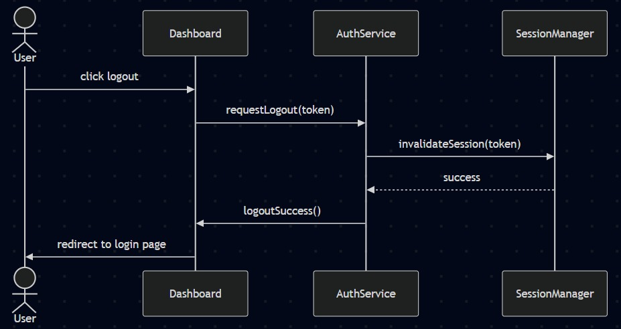

10. Generate Revenue Report
Sequence Diagram:

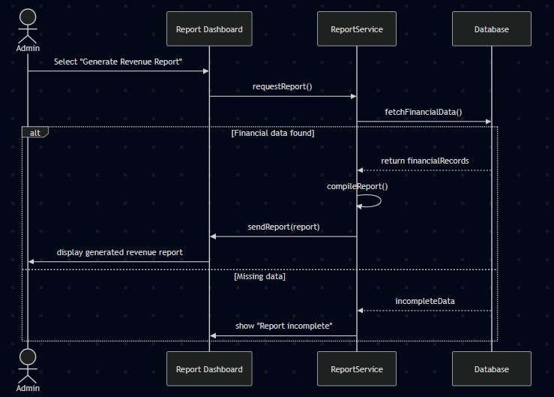

11. Generate Driver Performance Report
Sequence Diagram:

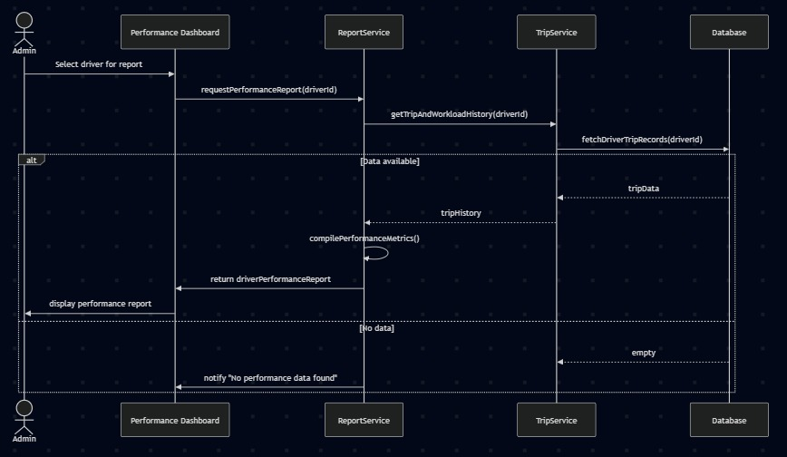

12. Authentication
Sequence Diagram:

